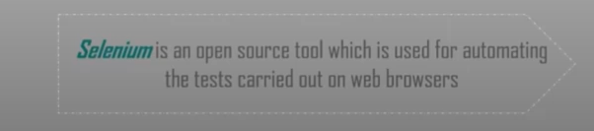

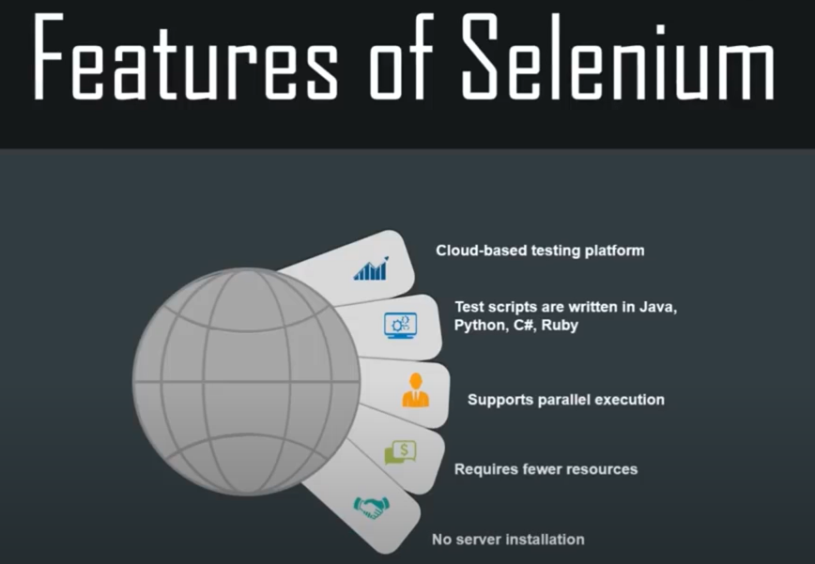

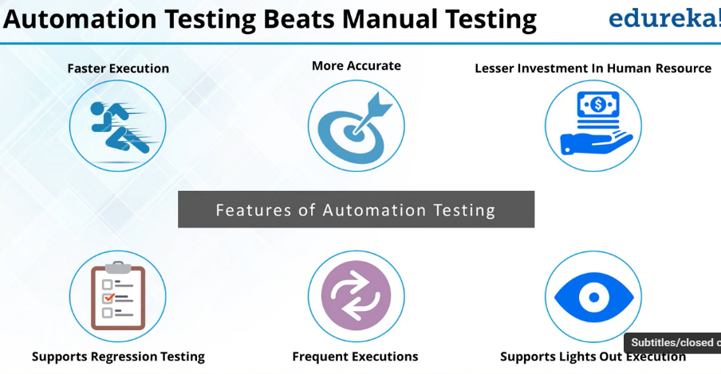

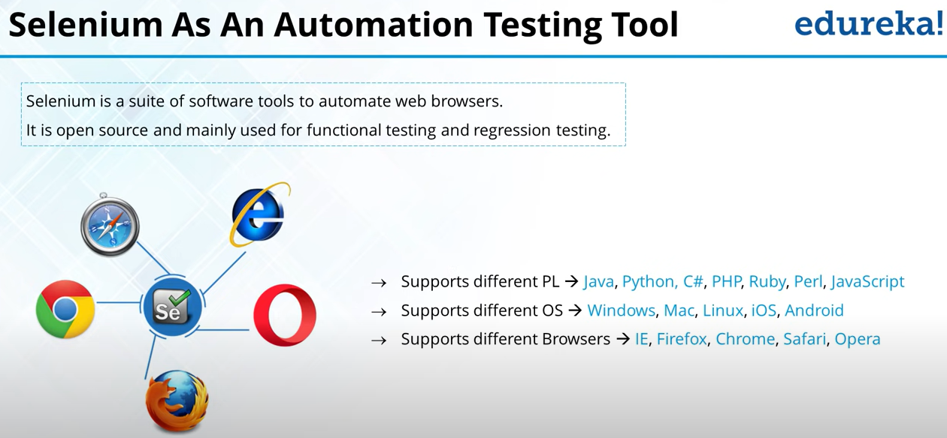

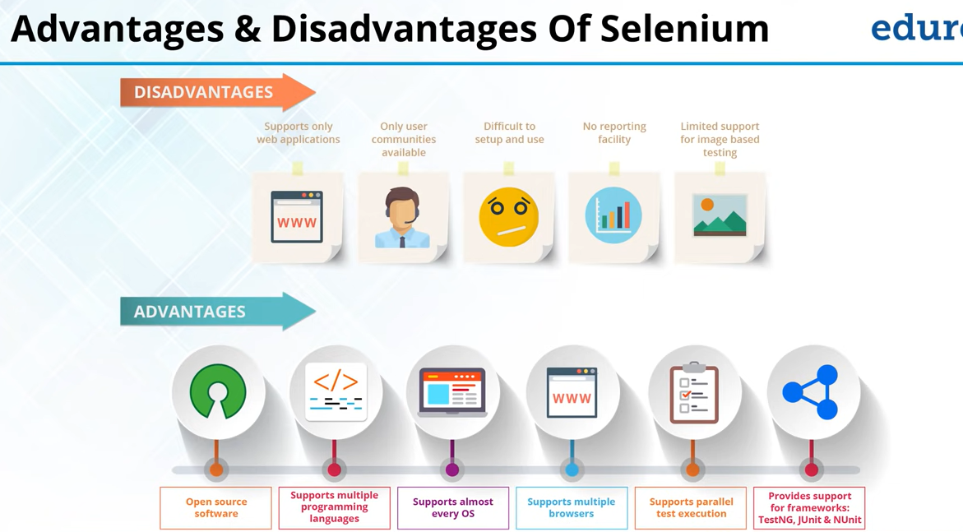

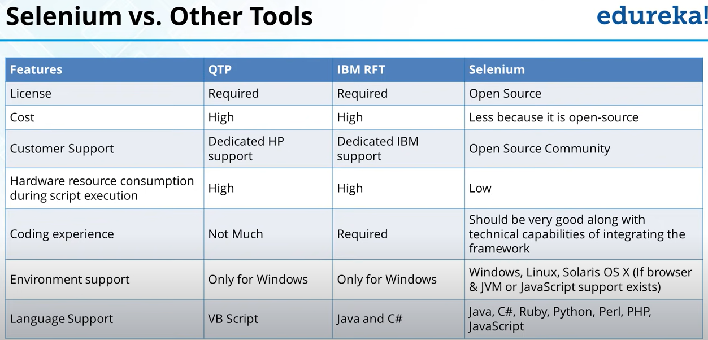

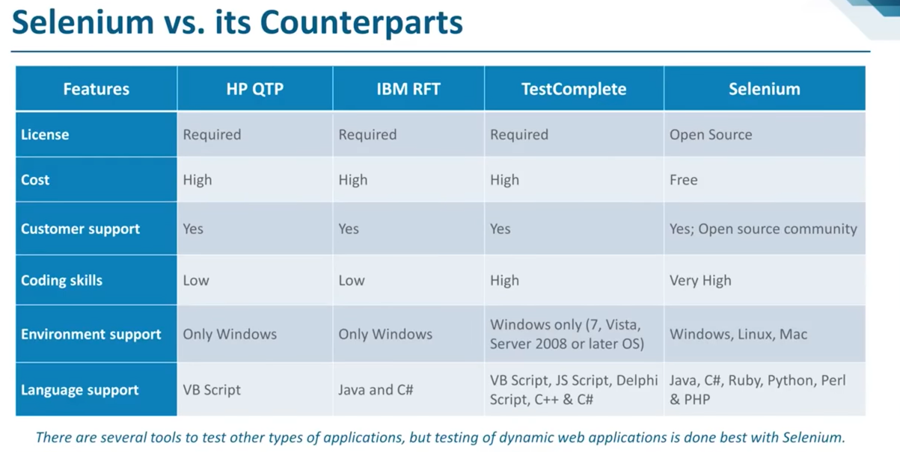

Dynamic web application is best tested with selenium .

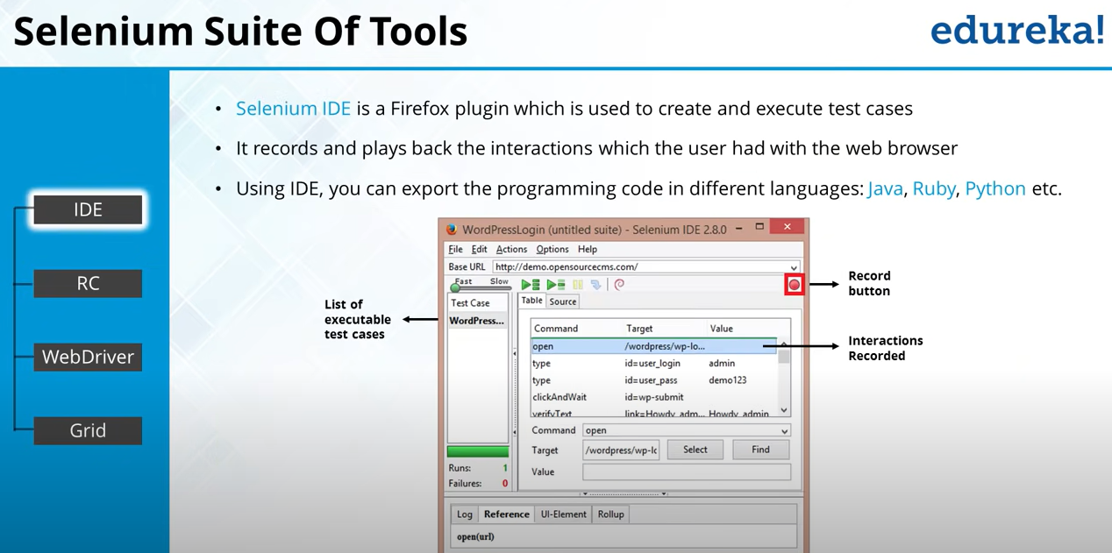

IDE : It’s like Firefox plugin

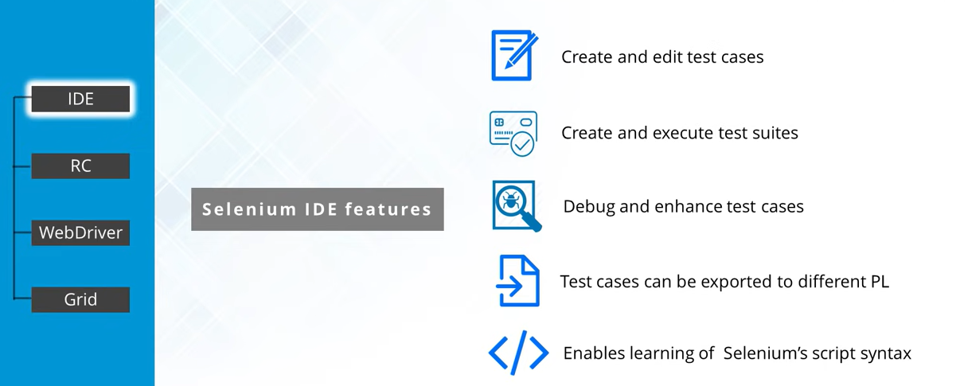

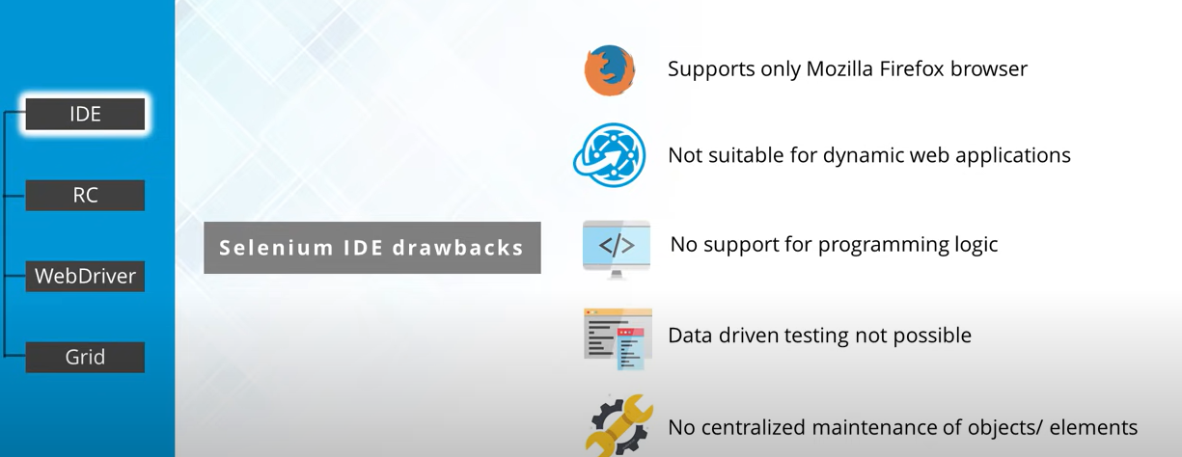

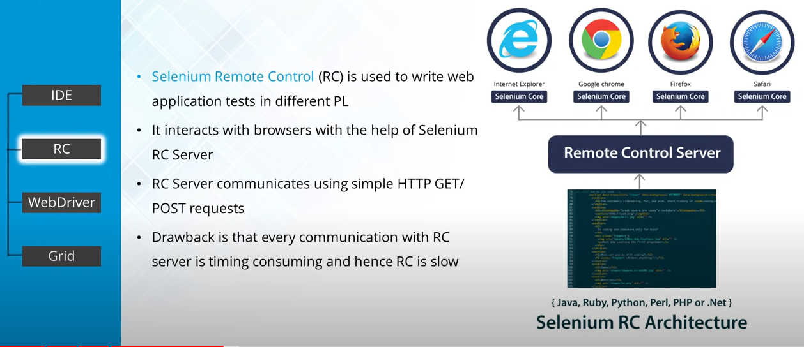

Selenium RC (Remote Control) : Using this you can perform cross browser testing .

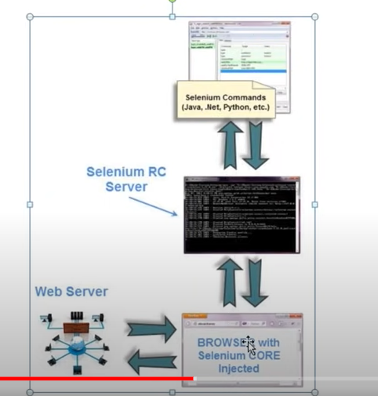

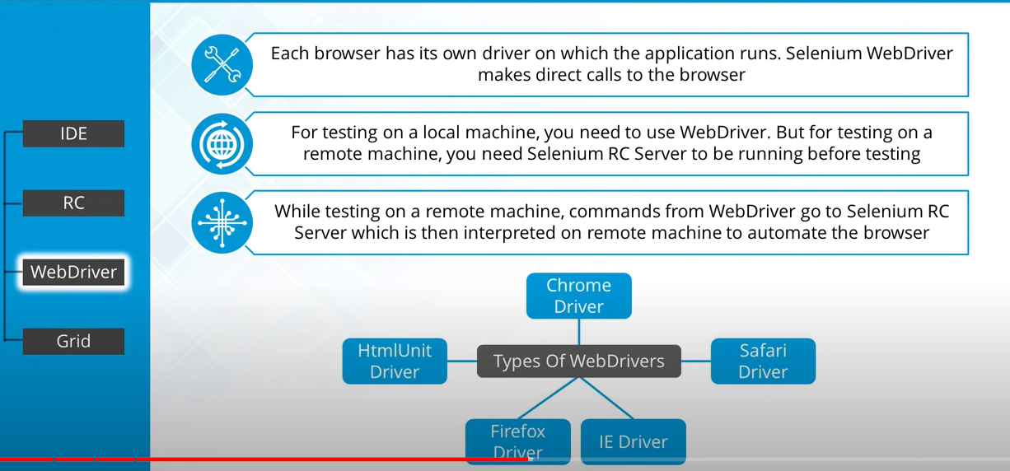

Selenium Web driver : Provide programming interface to create and executes test cases .

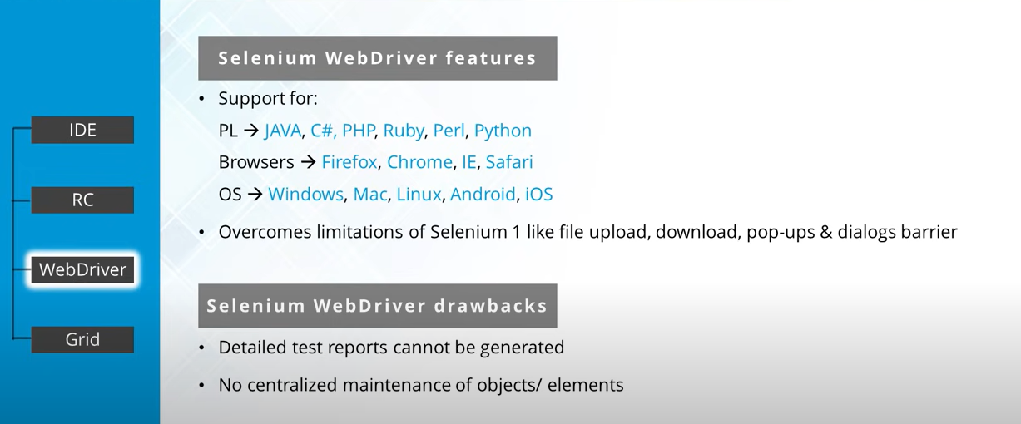

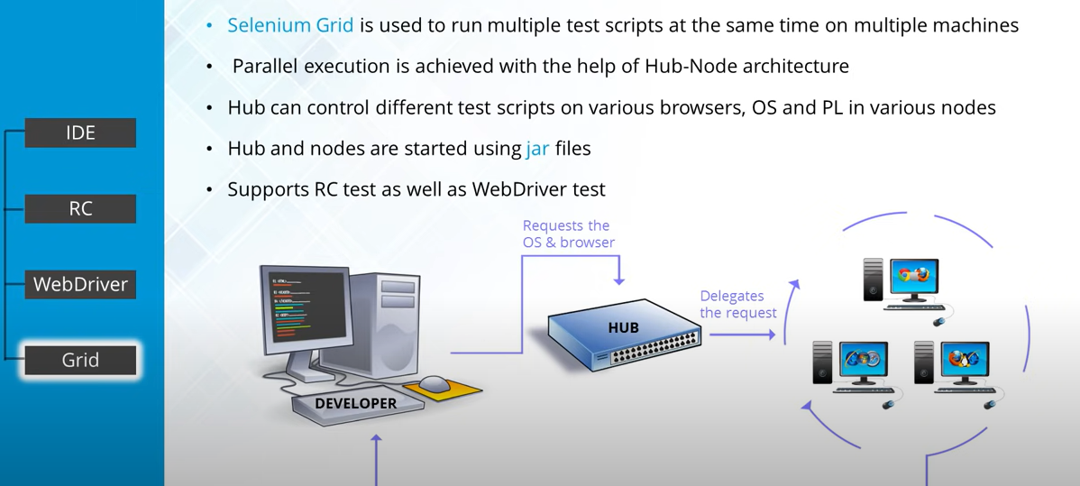

Selenium Grid :

Web Elements :

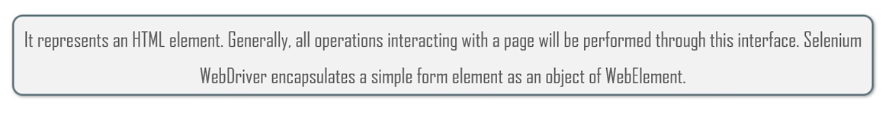

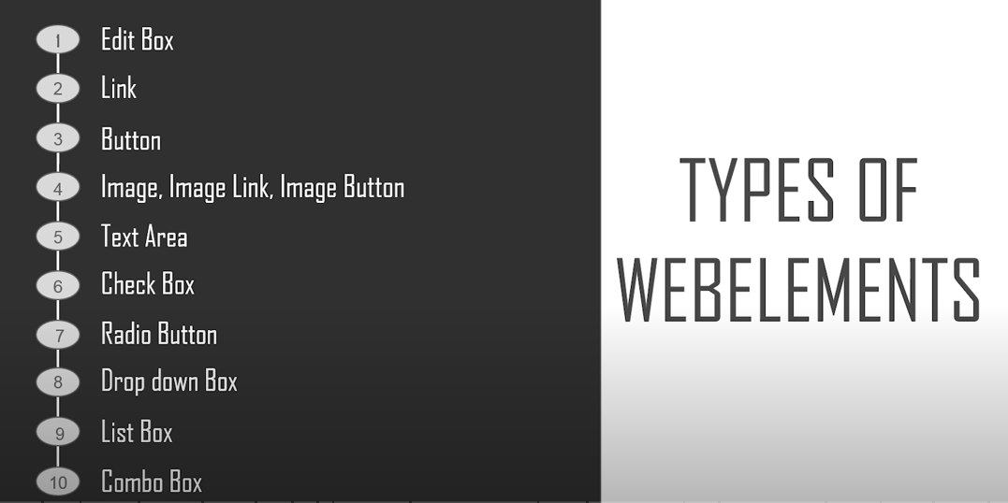

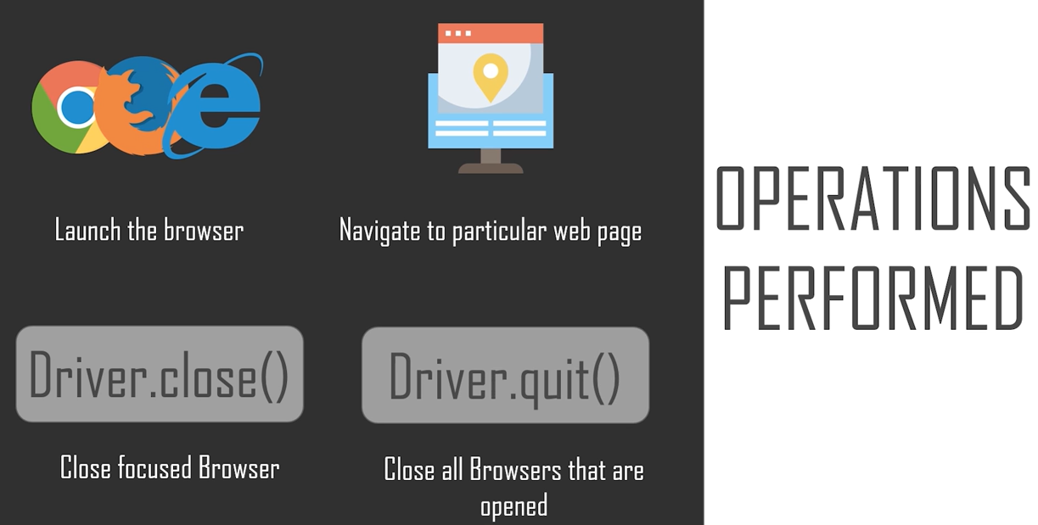

Navigate forward , back , refresh , maximize screen

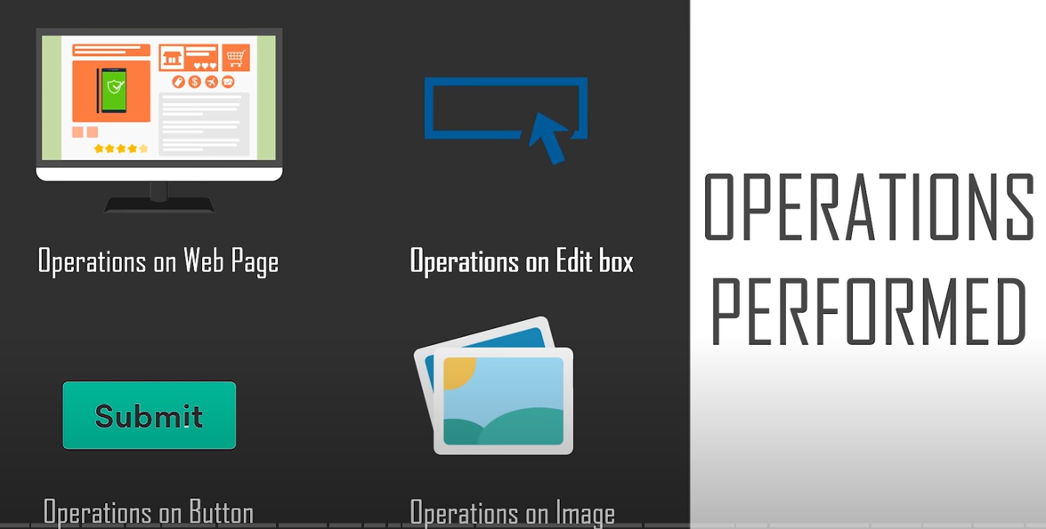

Web page -> get URL ,

Edit box -> enter value , clear value , check enable status

Submit : Click , display status

Images : no function (General image ), image button , image link,

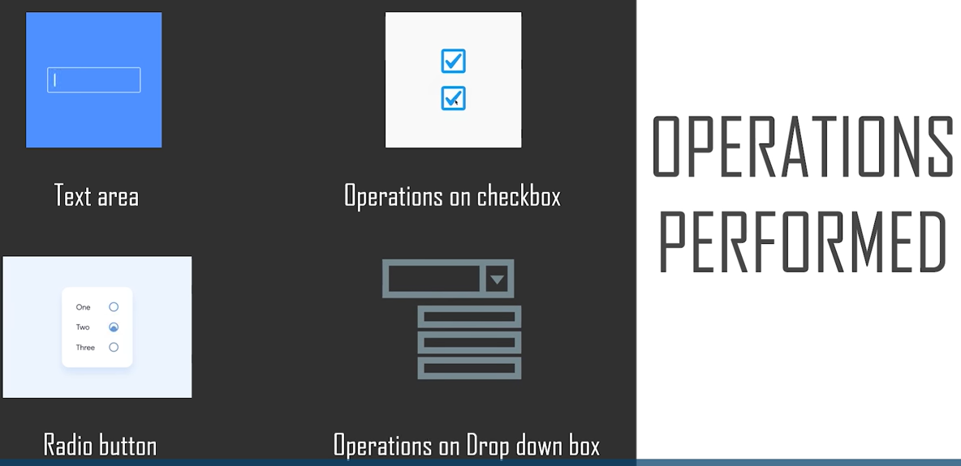

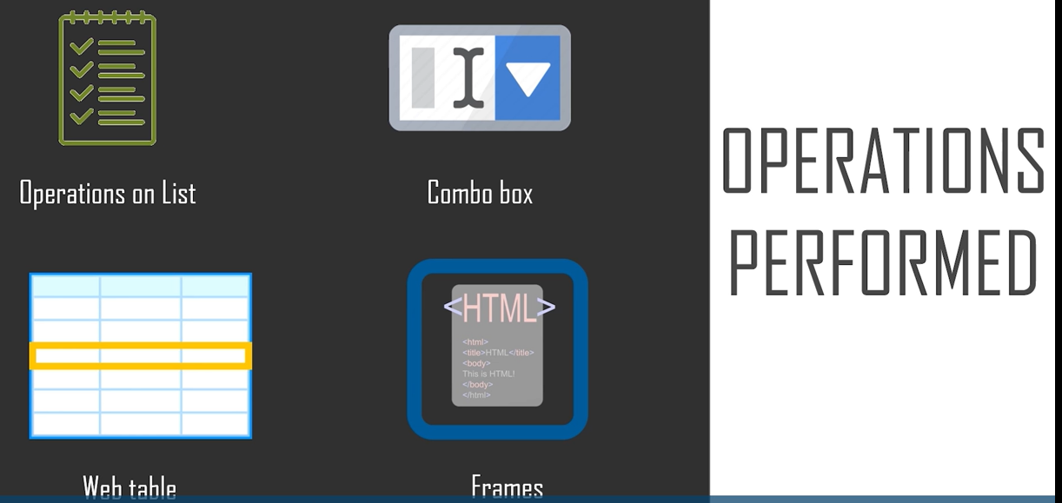

Regression test : Test Major functionality or components , After bug fix or enhancement (add more feature ) ,

Selenium is used to automate functional and regression testing .

Functional testing : Dividing a test case on the basis of components / call flows .

Automation testing : Write some scripts to run test cases (Create automation test suite).

Disadvantages :

1. Supports only web application (not mobile app browser /desktop application), not for image based testing ,

Advantages

1. Selenium jars download.
2. Supports parallel test execution. (Cross browser testing)-> running same test cases parallel in 2 different browser / OS. (Using TestNG along with selenium Web driver / Grid)
3. Provide support for different framework (TestNG , JUnit Java Unit Testing Framework, NUnit used for C lang)
4. TestNg Test Next Generation (Advanced version of Junit) -> Give well formed HTML reports .

Testing a dynamic web application

Runner Server -> Sending instruction to Core -> Core sending instruction to browser .

Web Driver

When ever you run a test case

1. Select on which browser I need to run my test cases (eg Chrome)
2. Before sending instruction , we need to run the server

Chrome -> chromedriver.exe (Can download)

FireFox -> geckodriver.exe

Internet Explorer -> iedriver.exe

Selenium web browser make direct call to browser .

Web driver on its own can’t create a report

Selenium Server Standalone (Jar which will help run node and hub)

We need some development environment such as eclipse or Intelijji (RC and web driver don’t have their web environment )

Selenium RC : Selenium Core(Open source Javascipt , Issue is same origin policy ) -> Selenium RC (Large processing time )

**Btw your script (USER) and application under test (BROWSER)**

[Selenium RC server , Selenum Core (Javascript program ) (Injected in browser)]

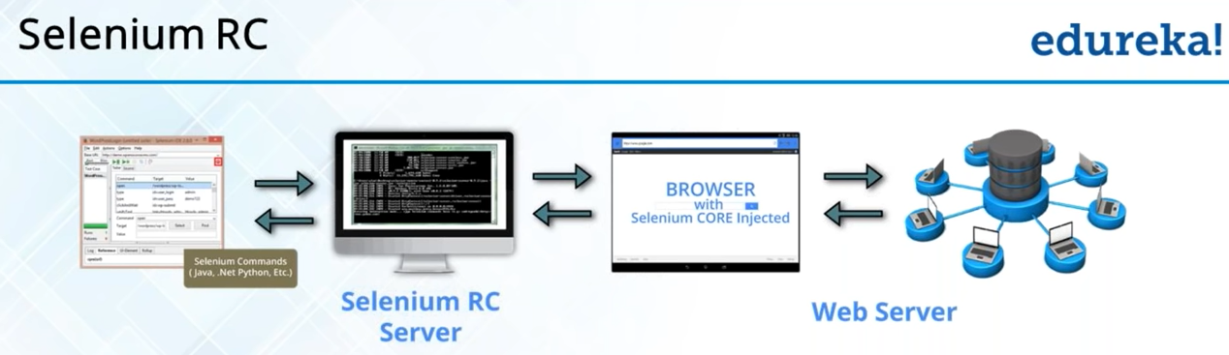

What is selenium ?

IT is a API (a programming interface)

Java : Programming language

Selenium : Used for API’s and Functions

TestNG : It is used to form reports . TestNG.xml file (Configuration file ) , Can do parallel testing .

Basic 6 Get Commonds :

Selenium Web Driver

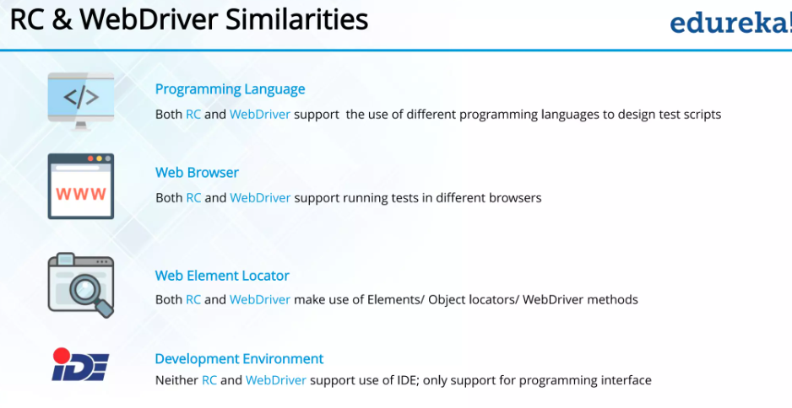

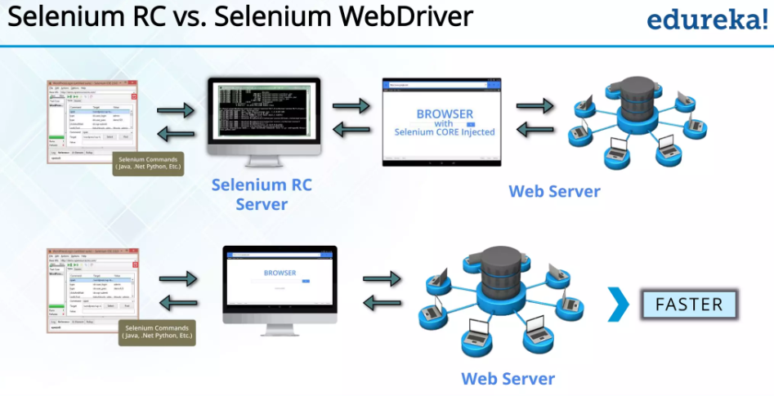

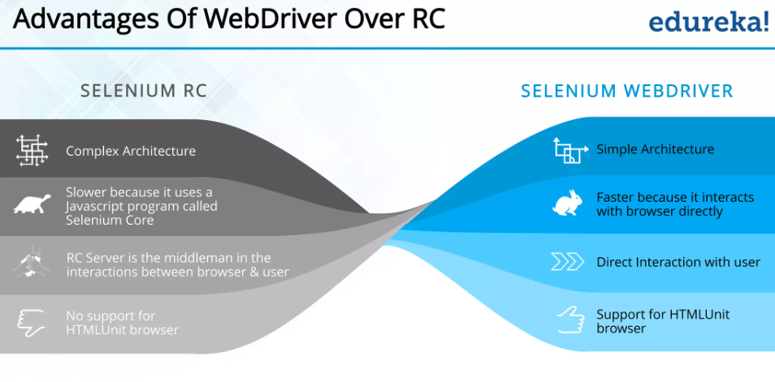

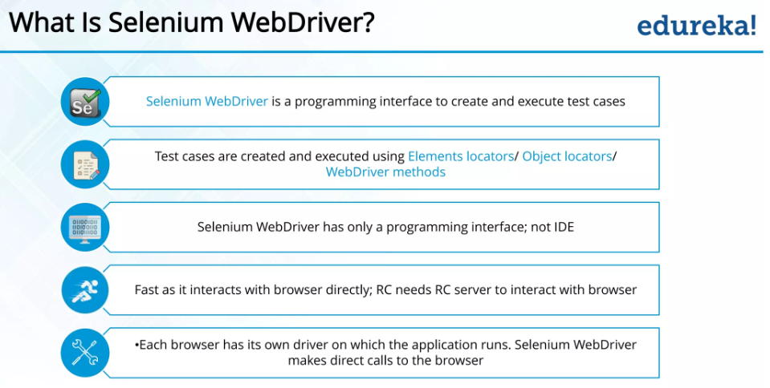

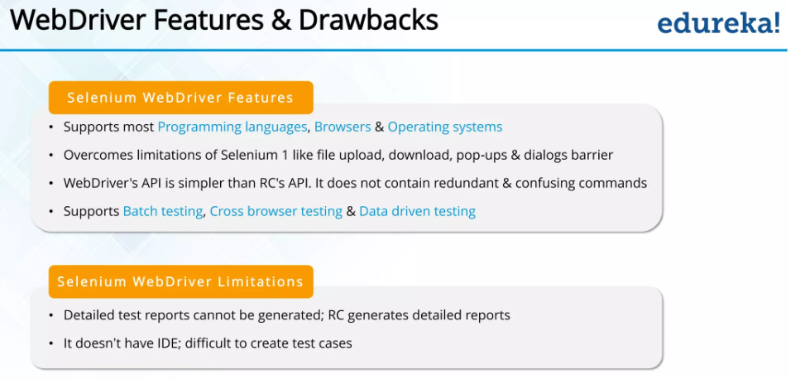

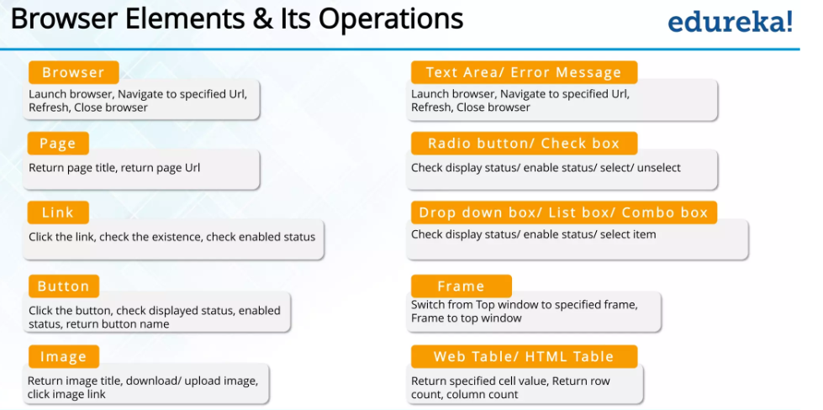

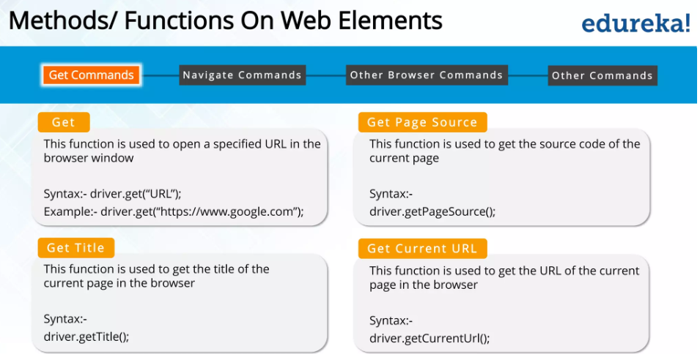

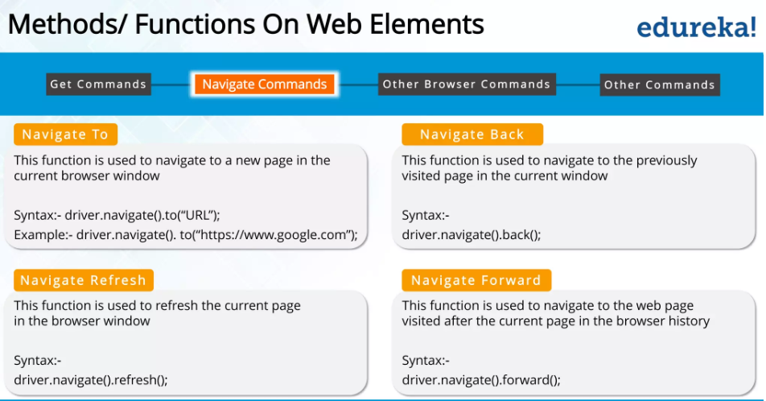

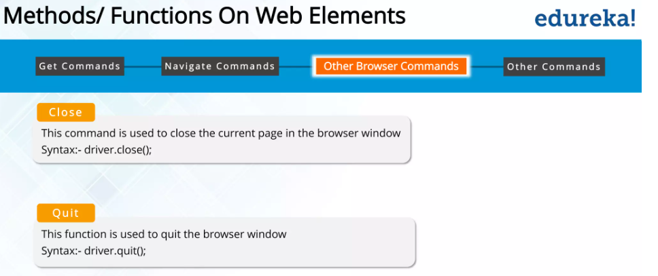

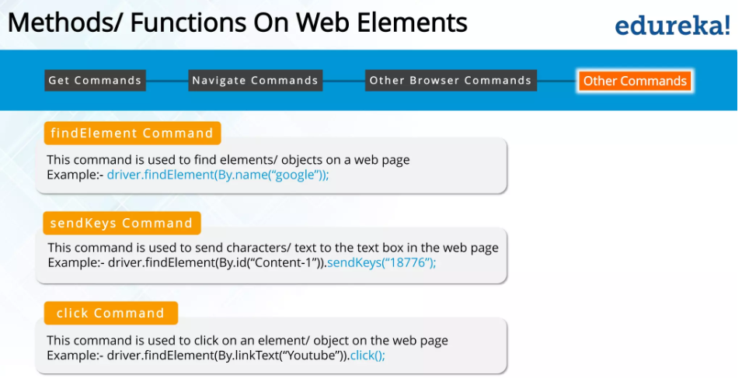

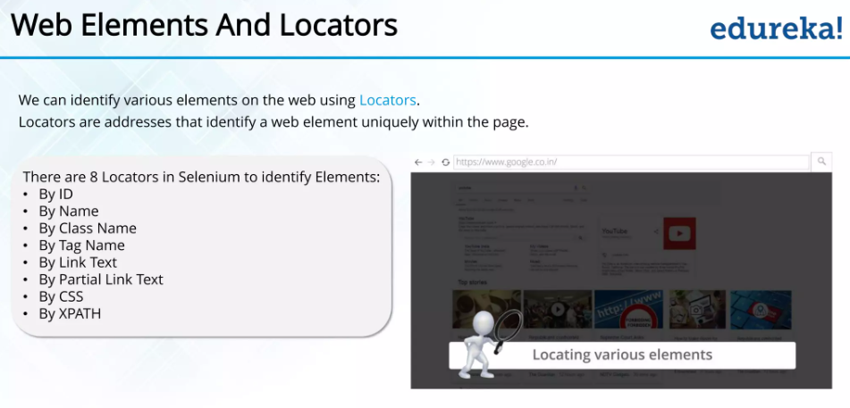

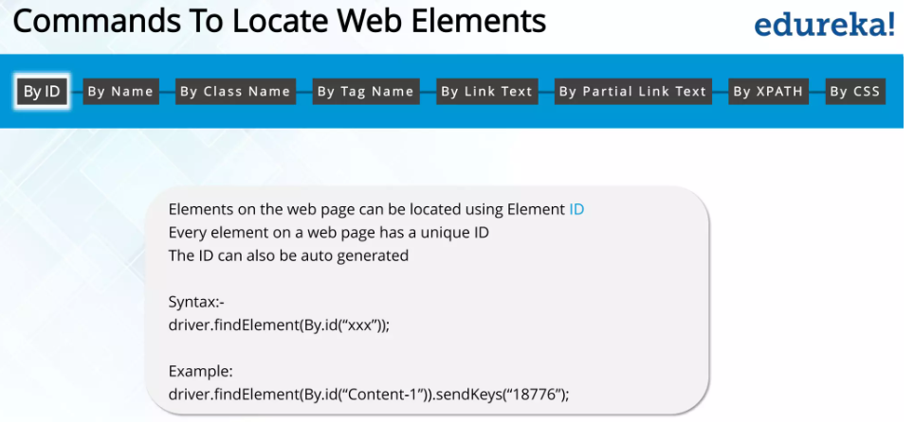

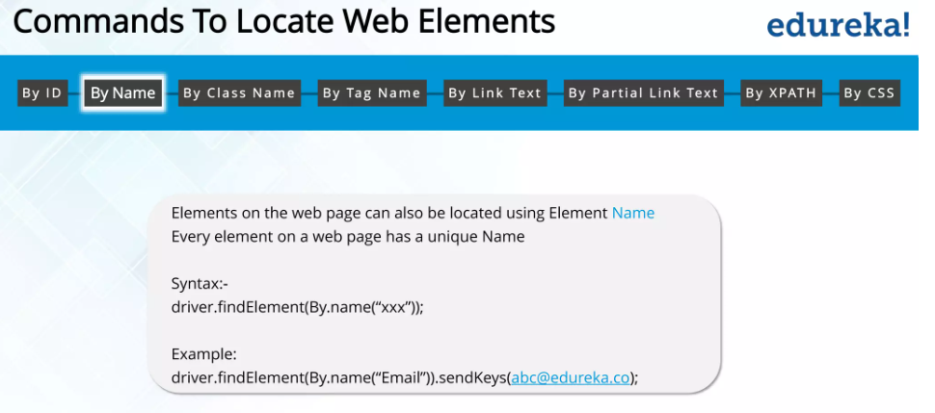

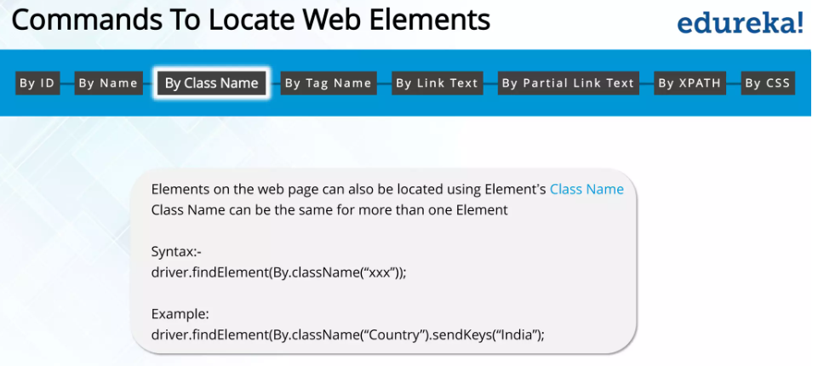

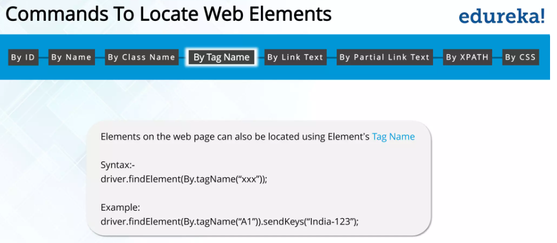

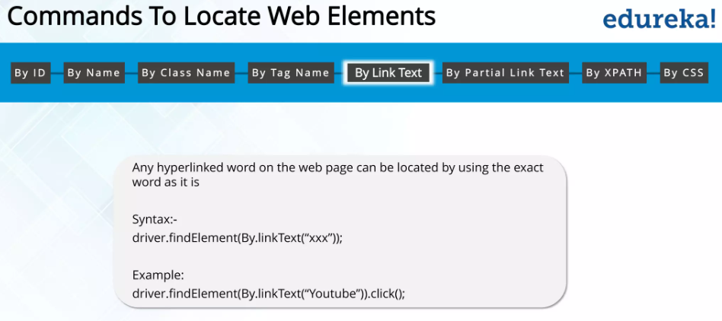

Link Text : text written in between

<a>Hello</a>

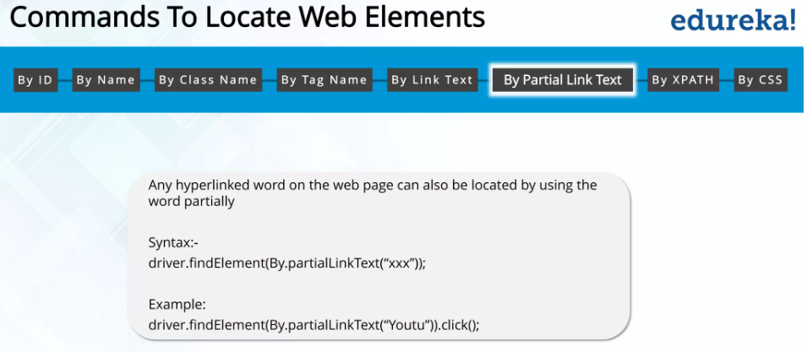

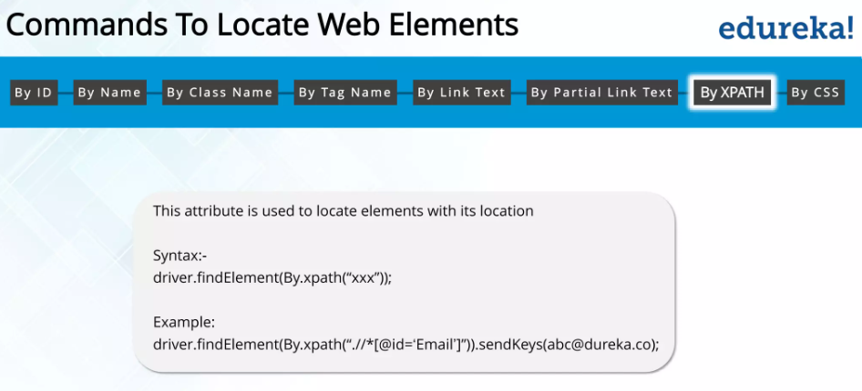

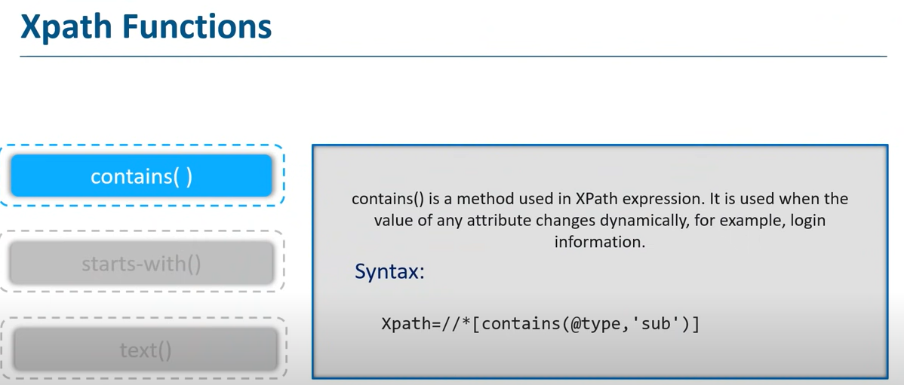

Xpath = //img[contains(@src , ‘sprites’)]

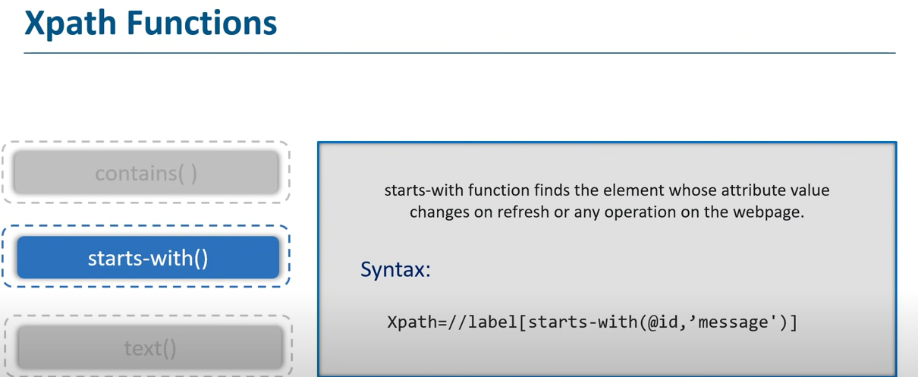

Xpath = //img[starts-with(@alt , ‘shop’)]

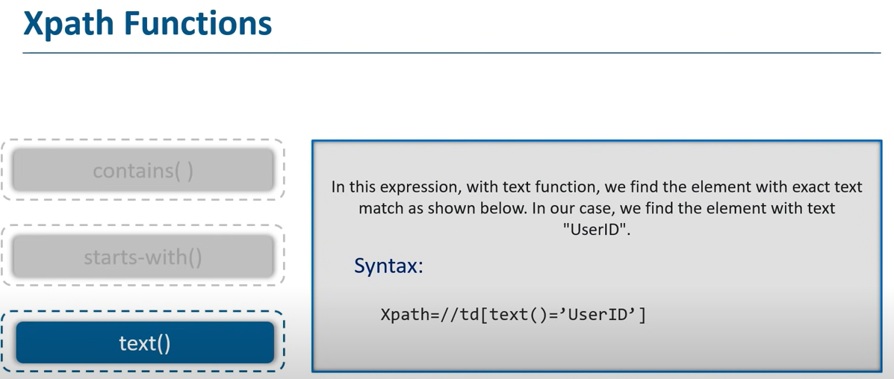

Can also use multiple at one time:

//input[@name=’username’] //input[@id=’login-username’]

// Can use extension cropath

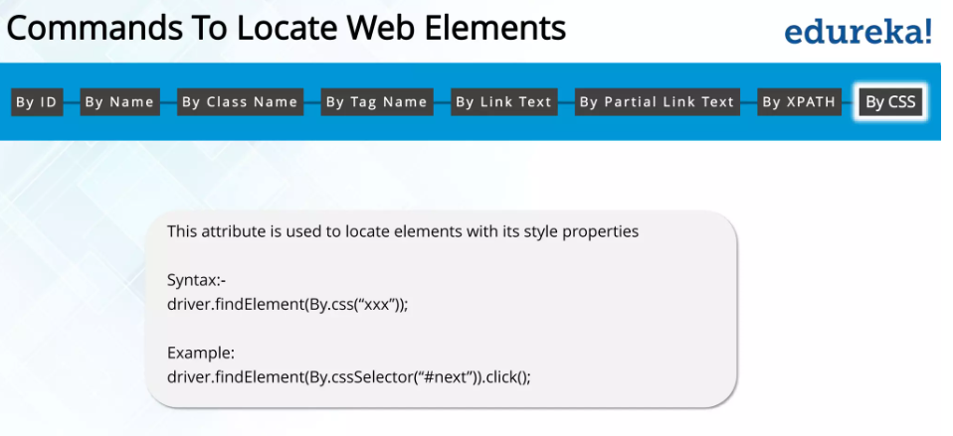

Selenium used locators to interact with these web elements .

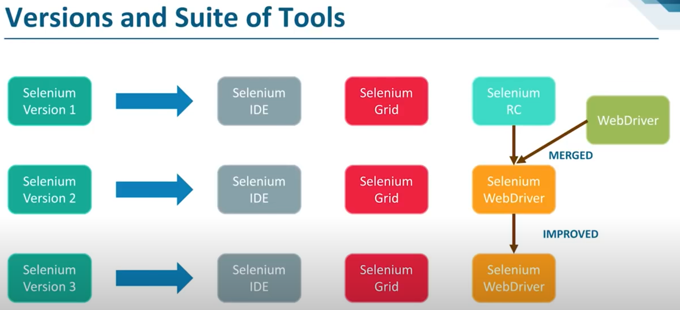

Selenium communicates Client Library, Create JSON payload and instance (JSON wire protocol) , Browser Driver sends request to respective browser (In form of HTTP request).

Locators in Selenium web Driver

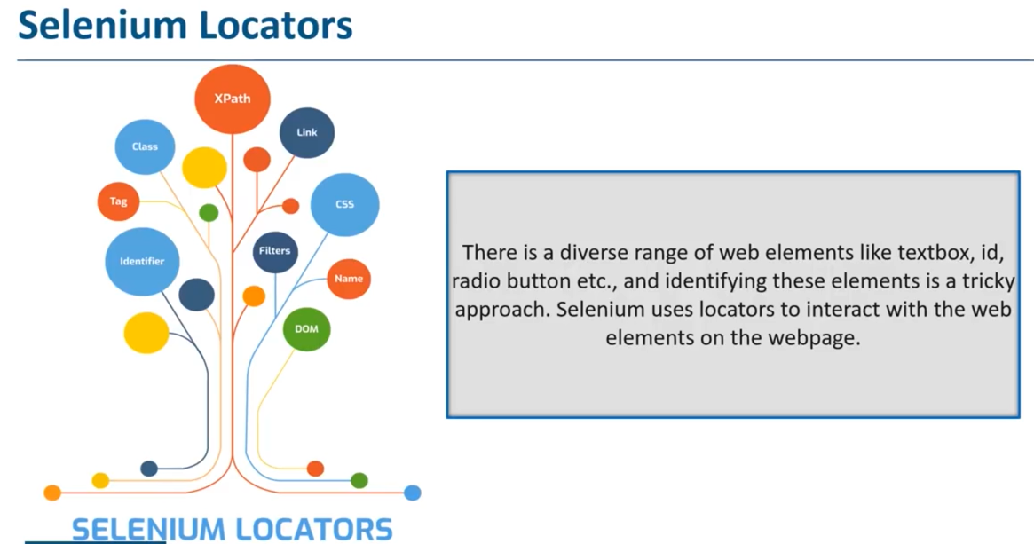

Choosing correct type of locator is important to accomplish desired task .

1. ID : Best

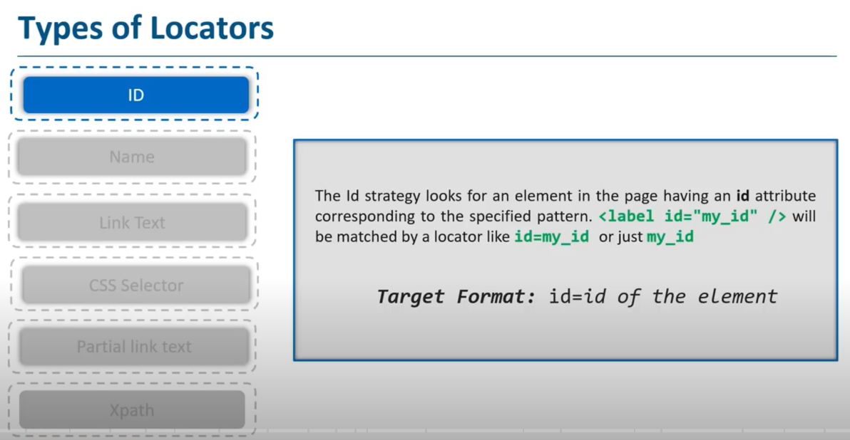

1. Name : First occurrence will return

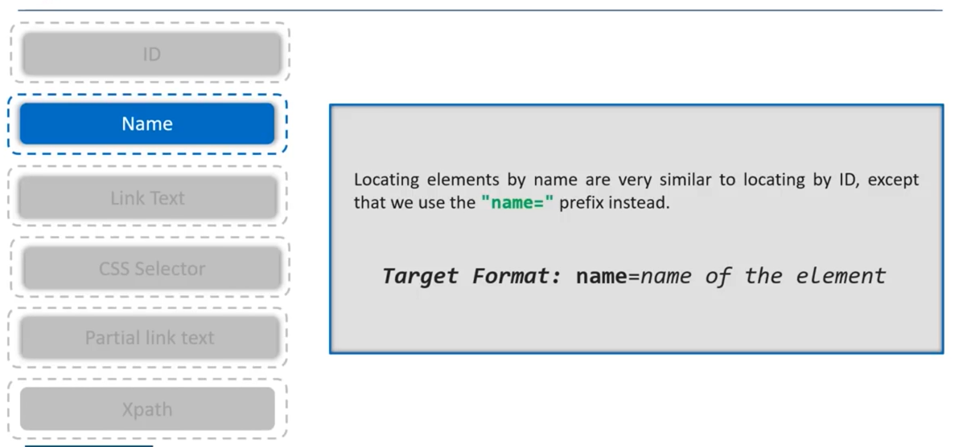

1. LinkText : Only to hyperlink text

<a href=’xyz’ > Submit </a>

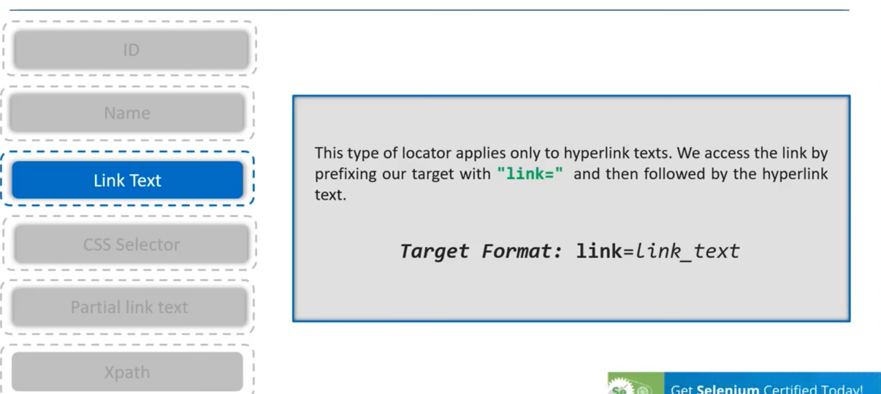

1. CSS Selector #login-username

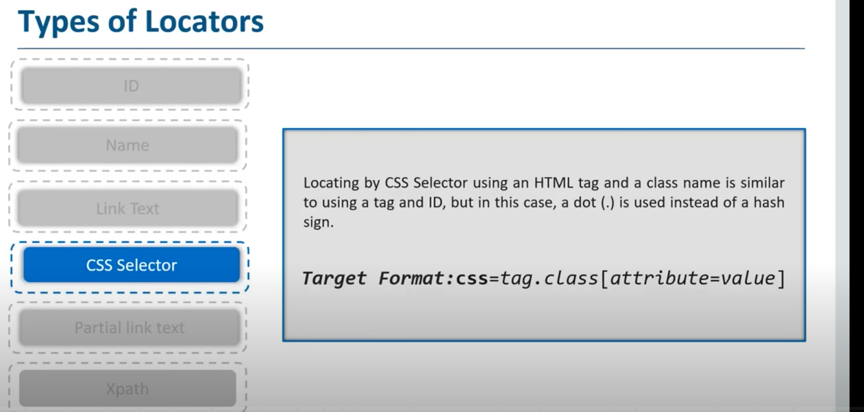

1. Do not write complete text : write some part of it [Submit ]

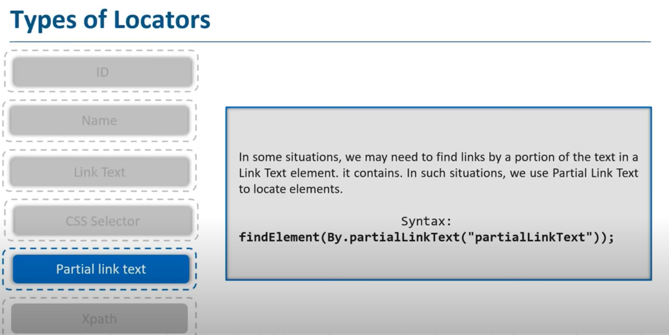

1. Xpath -> absolute , relative

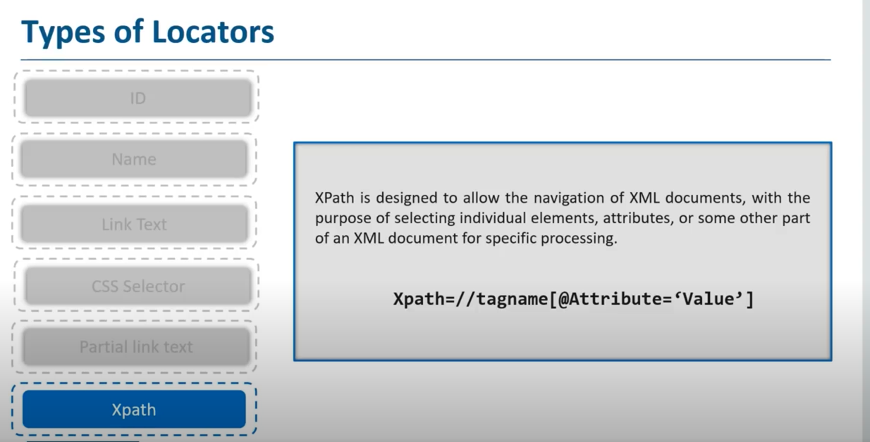

Waits in selenium :

Selenium throws an 'ElementNotVisibleException' message when you tend to locate an element present in your script which is still not loaded on the web page.

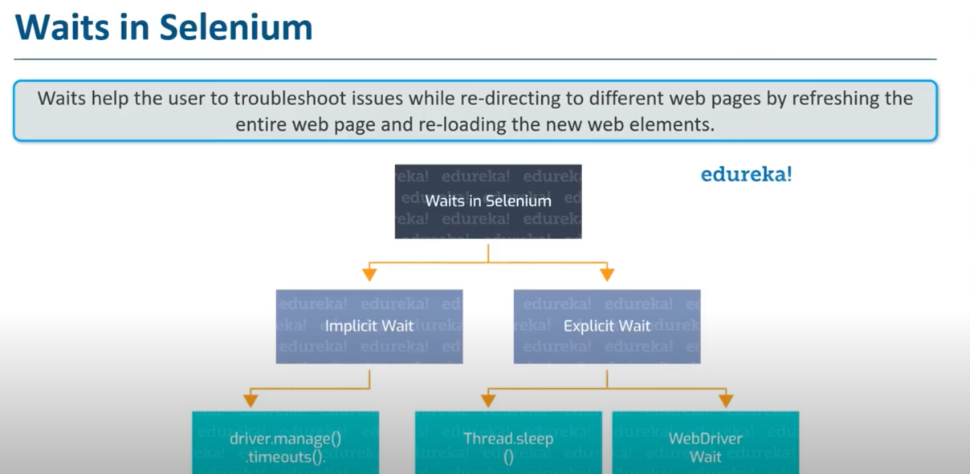

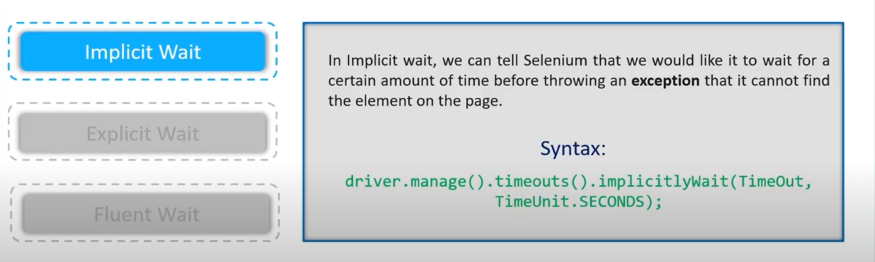

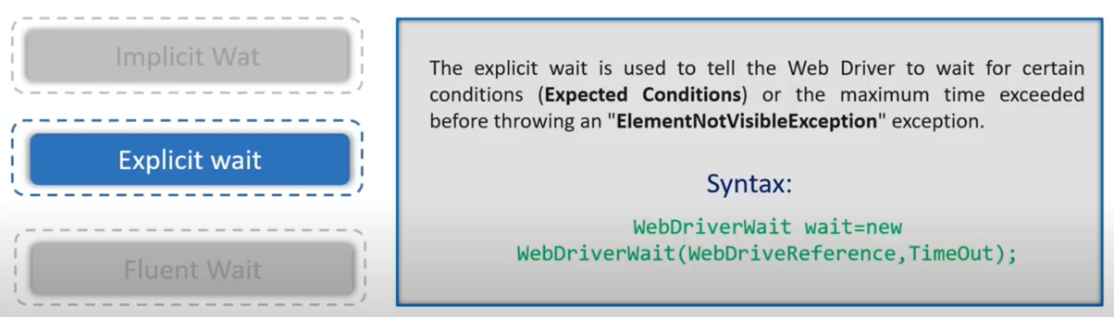

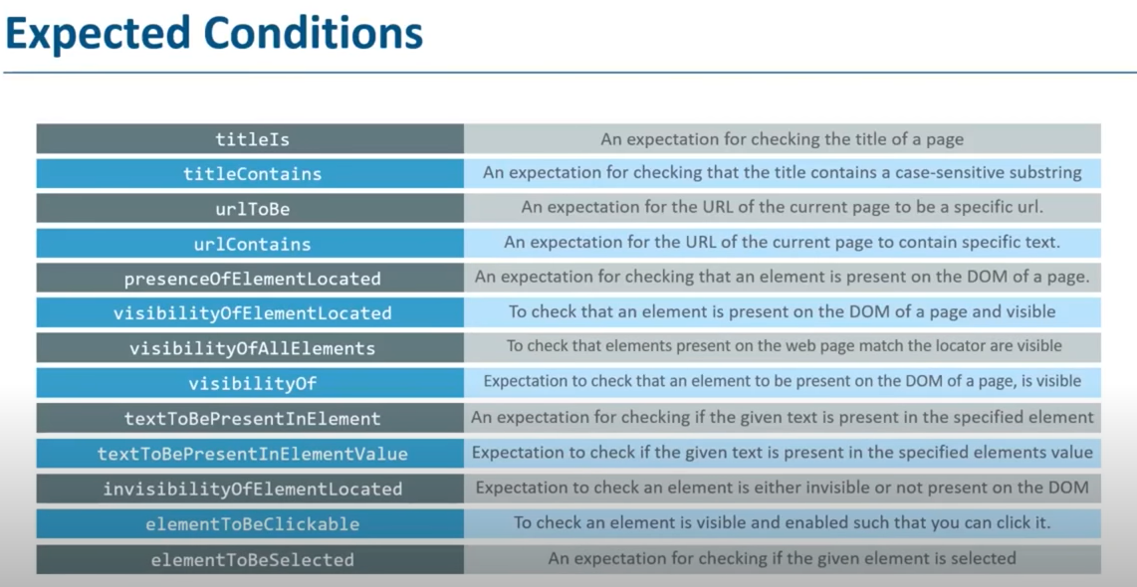

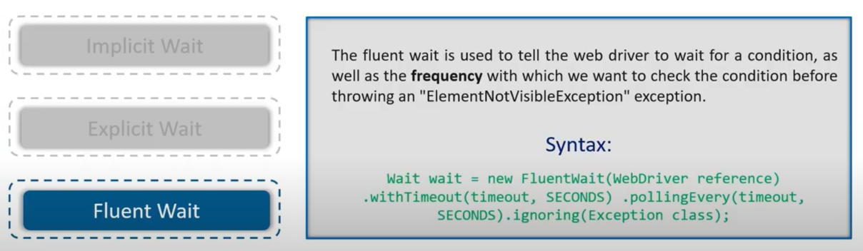

Alert in Selenium

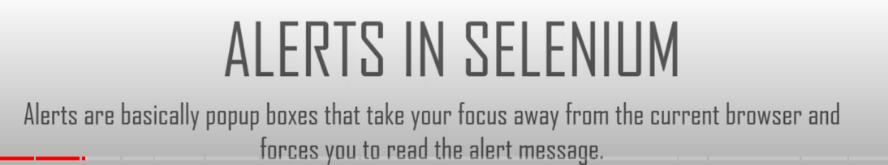

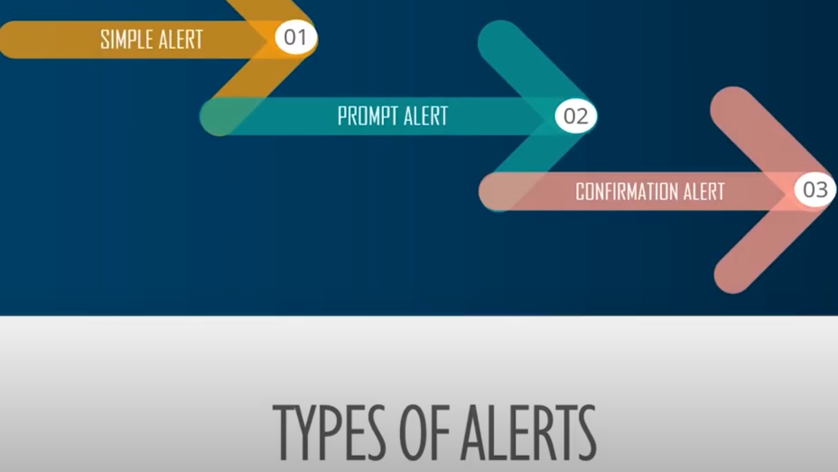

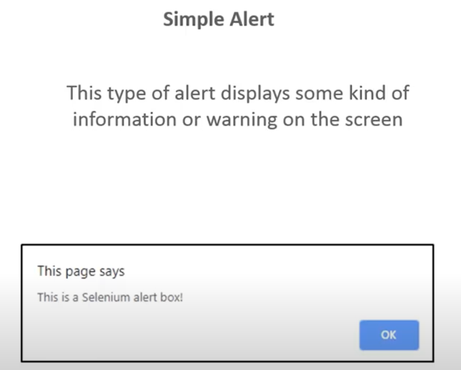

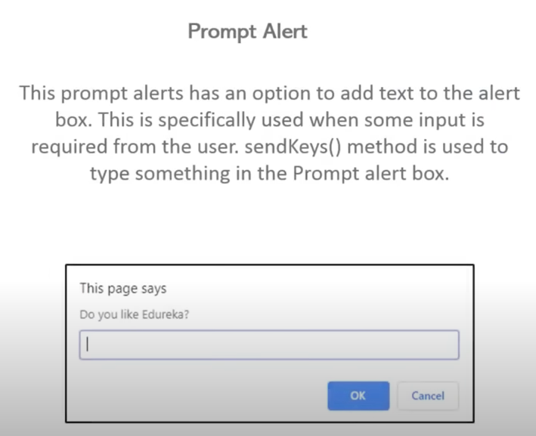

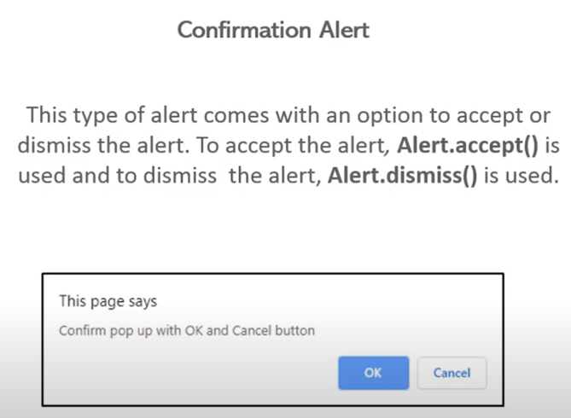

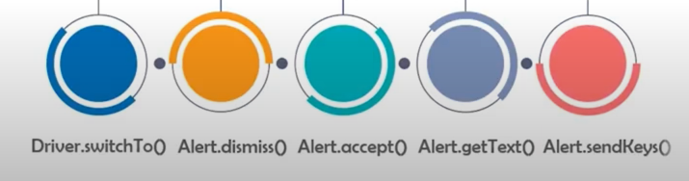

1) void dismiss() // To click on the ‘Cancel’ button of the alert.

driver.switchTo().alert().dismiss();

2) void accept() // To click on the ‘OK’ button of the alert.

driver.switchTo().alert().accept();

3) String getText() // To capture the alert message.

driver.switchTo().alert().getText();

4) void sendKeys(String stringToSend) // To send some data to alert box.

driver.switchTo().alert().sendKeys("Text");

In Selenium web driver there are methods through which we can handle multiple windows.

* Driver.getWindowHandles();

To handle all opened windows by web driver, we can use “Driver.getWindowHandles()”

and then we can switch window from one window to another in a web application.

Its return type is Iterator<String>.

* Driver.getWindowHandle();

When the site opens, we need to handle the main window by driver.getWindowHandle().

This will handle the current window that uniquely identifies it within this driver instance.

Its return type is String.

Exception handling in Selenium

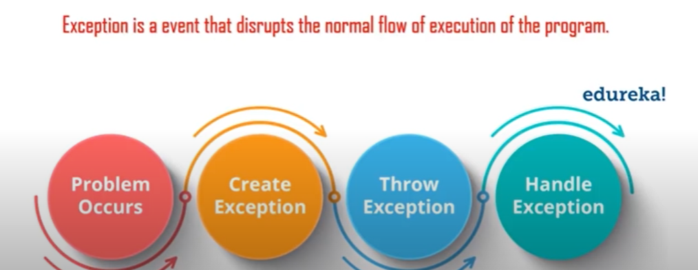

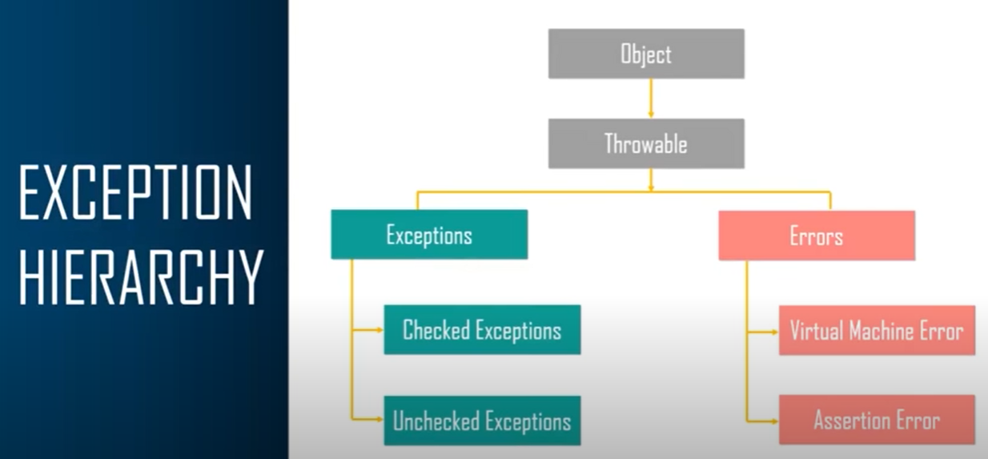

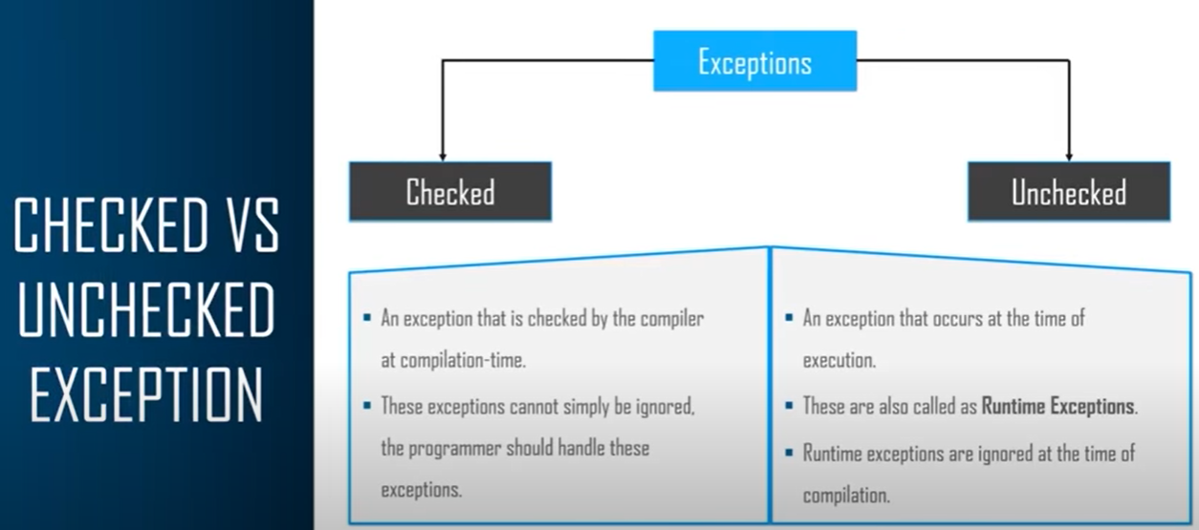

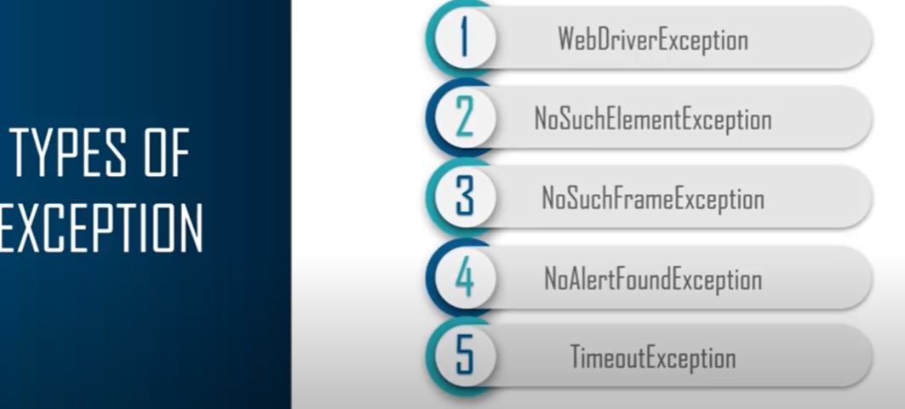

Exception handling is a process or a mechanism that detects and resolves runtime exceptions and communication errors in Selenium.

**Throw vs Throws in Java**

**The Throw Keyword:**

The throw keyword is used to throw an exception explicitly by the programmer

if ( b===0 ) {

throw new ArithmeticException("Div by 0");

}

else{

return a/b ;

}

The throws Keyword

Throws java throws keyword is used to declare an exception.

This gives an information to the programmer that there might be an exception so its better to be prepared with a try catch block!

public void calculate (int a, int b) throws IOException {

// code

}

package com.company;

class NegativeRadiusException extends Exception{

@Override

public String toString() {

return "Radius cannot be negative!";

}

@Override

public String getMessage() {

return "Radius cannot be negative!";

}

}

public class cwh_84_throw_throws {

public static double area(int r) throws NegativeRadiusException{

if (r<0){

throw new NegativeRadiusException();

}

double result = Math.PI * r * r;

return result;

}

public static int divide(int a, int b) throws ArithmeticException{

// Made By Harry

int result = a/b;

return result;

}

public static void main(String[] args) {

// Shivam - uses divide function created by Harry

try{

// int c = divide(6, 0);

// System.out.println(c);

double ar = area(6);

System.out.println(ar);

}

catch(Exception e){

System.out.println("Exception");

}

}

}

**Try Catch Finally**

1. try: The try block contains a set of statements where an exception can occur.

try

{

// statement(s) that might cause exception

}

2. catch: The catch block is used to handle the uncertain condition of a try block. A try block is always followed by a catch block, which handles the exception that occurs in the associated try block.

catch

{

// statement(s) that handle an exception

// examples, closing a connection, closing

// file, exiting the process after writing

// details to a log file.

}

3. throw: The throw keyword is used to transfer control from the try block to the catch block.

4. throws: The throws keyword is used for exception handling without try & catch block. It specifies the exceptions that a method can throw to the caller and does not handle itself.

5. finally: It is executed after the catch block. We use it to put some common code (to be executed irrespective of whether an exception has occurred or not ) when there are multiple catch blocks.

Listeners in Selenium

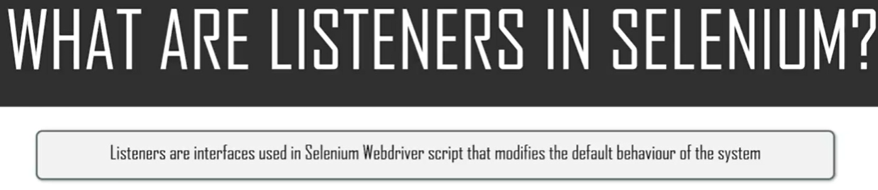

Types of List

1. Web Driver Listeners
2. TestNG Listeners

Listeners are TestNG annotations that literally “listen” to the events in a script and modify TestNG behaviour accordingly. These listeners are applied as interfaces in the code. For example, the most common usage of listeners occurs when taking a screenshot of a particular test that has failed along with the reason for its failure. Listeners also help with logging and generating results.

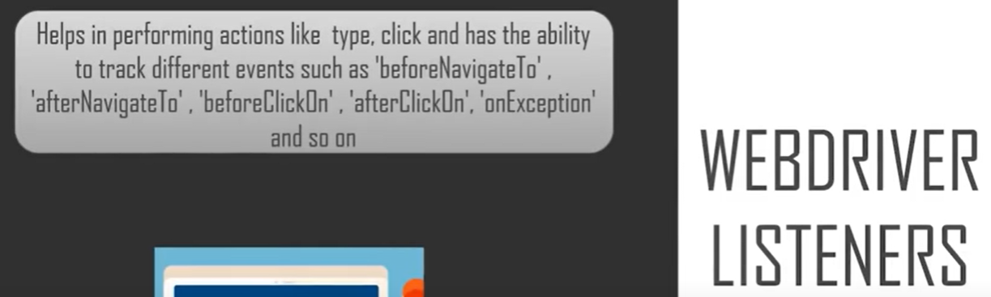

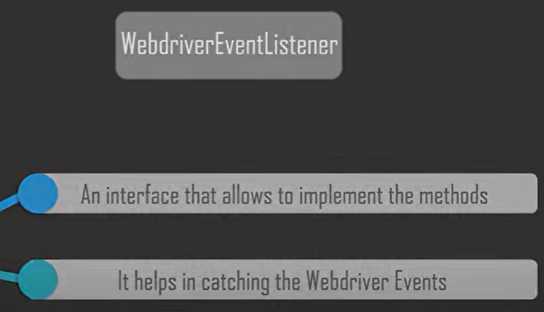

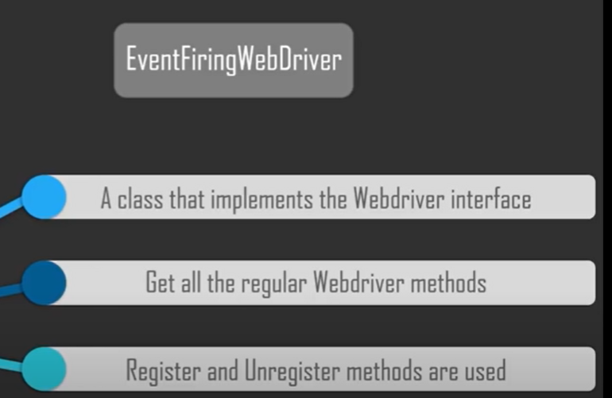

Test NG (Test Next Generation)

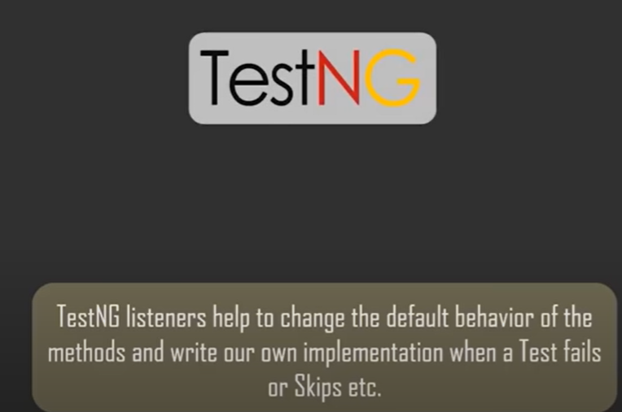

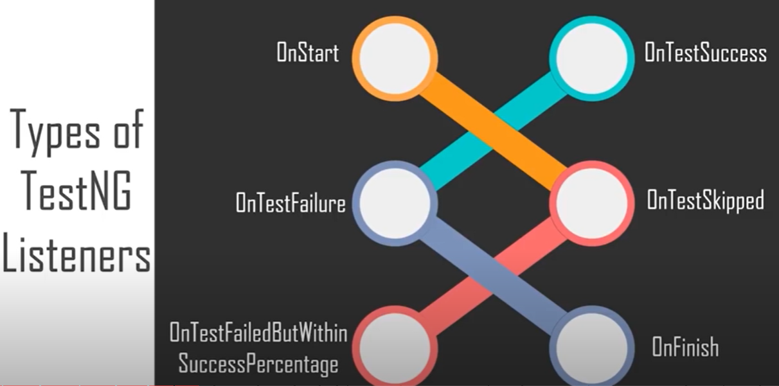

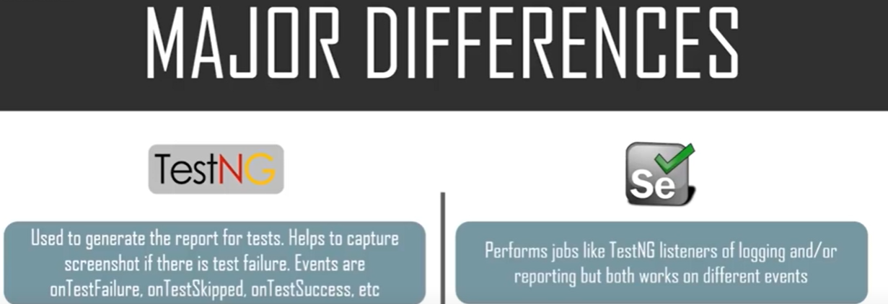

Test NG

* Inspired by Junit and Nunit

